* This project covers:

Microsoft Fabric End to End project.

It covers-

* Loading the data into the **lakehouse** as it is.
* Then using **SQL Endpoint for Data transformation,** changing a few of the data types and creating new custom columns.
* Once new columns are created, then creating **semantic model.**
* Finally creating a **Power BI dashboard.**

***Steps:***

1. Click on the new item and select Lakehouse.

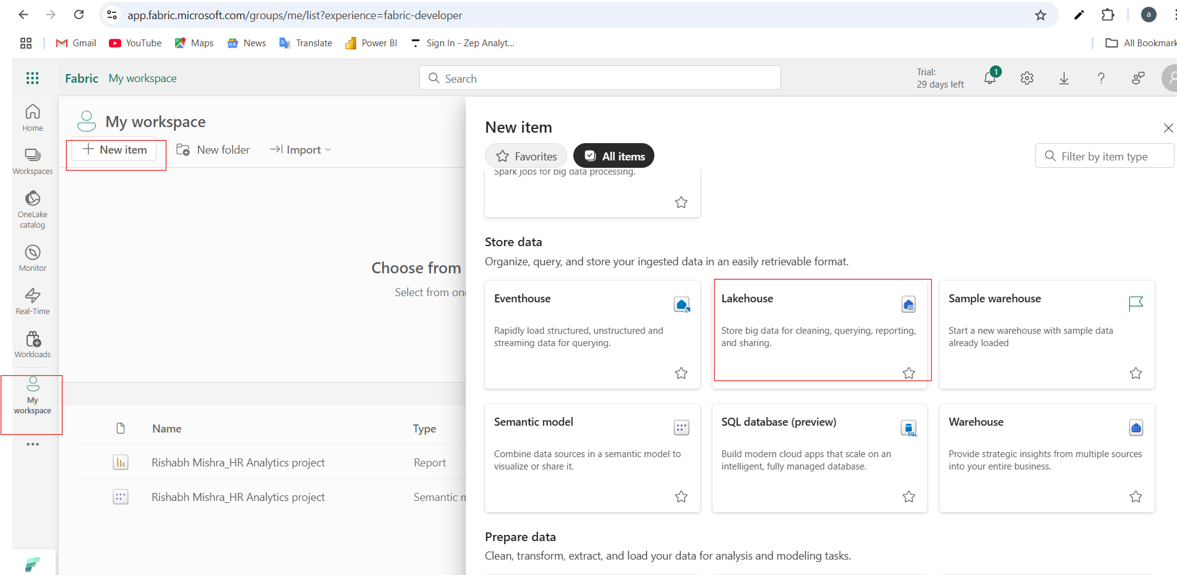

1. Upload the csv file in the lakehouse.

1. We converted the csv file to table using the option Load to tables.

1. We need to make some changes to the data like creation date has string data type, we need to make it date data type. For all these changes, we can use SQL Endpoint.

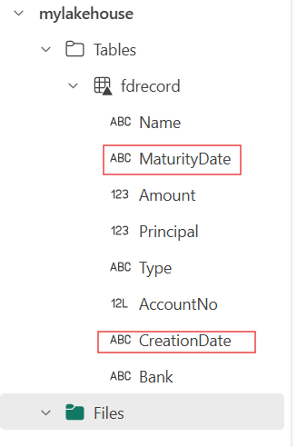

1. We are using SQL Endpoint for 2 things here:
2. Changing the data type of maturity date and creation date from string / text type to date type.
3. Creating some derived columns like interest rate, tenure

So to use SQL Endpoint change option on the top right from lakehouse to SQL Analytics Endpoint. This has same features like Azure SQL.

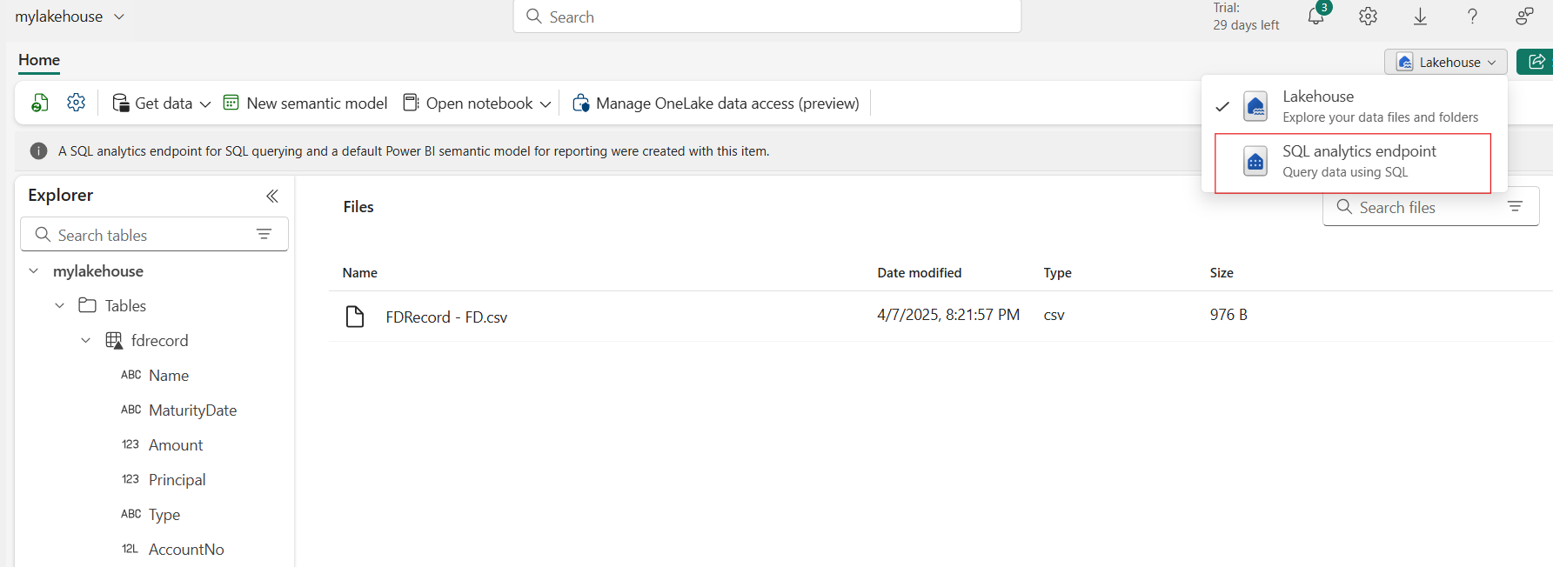

1. Click on new sql query.

1. Here we are creating the view.

The view has primarily two purposes:

* Simplify the complex SQL queries.
* Provide restrictions to users from accessing sensitive data.

View v_fdrecord was created.

***Query used to create the view:***

CREATE VIEW v_fdrecord AS

SELECT

Name,

TRY_CAST(MaturityDate AS DATE) AS MaturityDate,

Amount,

Principal,

Type,

AccountNo,

TRY_CAST(CreationDate AS DATE) AS CreationDate,

Bank,

DATEDIFF(year, TRY_CAST(CreationDate AS DATE), TRY_CAST(MaturityDate AS DATE)) AS NumberOfYears,

((Amount - Principal) /

NULLIF(CAST(Principal AS FLOAT) * NULLIF(DATEDIFF(year, TRY_CAST(CreationDate AS DATE), TRY_CAST(MaturityDate AS DATE)), 0), 0)

) * 100 AS InterestRate,

Principal * POWER(

1 + ((Amount - Principal) /

NULLIF(CAST(Principal AS FLOAT) * NULLIF(DATEDIFF(year, TRY_CAST(CreationDate AS DATE), TRY_CAST(MaturityDate AS DATE)), 0), 0)

),

DATEDIFF(year, TRY_CAST(CreationDate AS DATE), GETDATE())

) AS CurrentValue,

CASE

WHEN TRY_CAST(MaturityDate AS DATE) < GETDATE() THEN 'Yes'

ELSE 'No'

END AS isExpired

FROM fdrecord;

1. So we transformed the data using the SQL Endpoint. Now we will add the table in semantic model so that we can build power BI Dashboard on top of it.

We will add the view which we have created in above step in the sematic model.

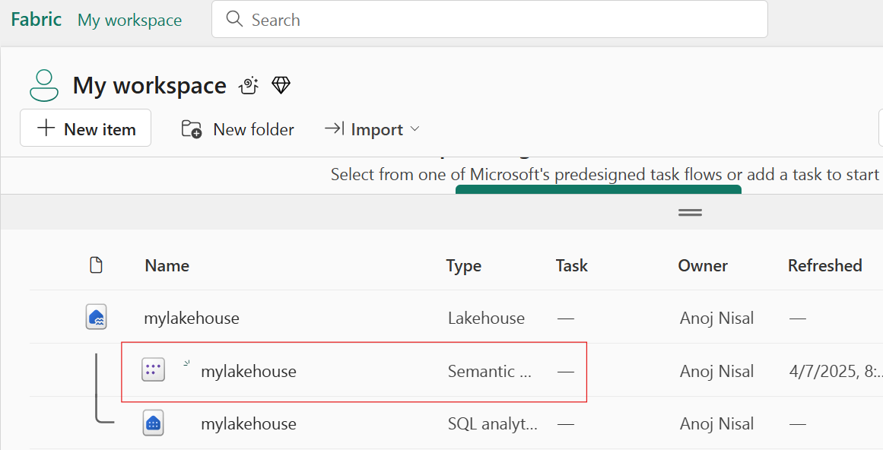

We can add the table / view to the default sematic model by using below method as well:

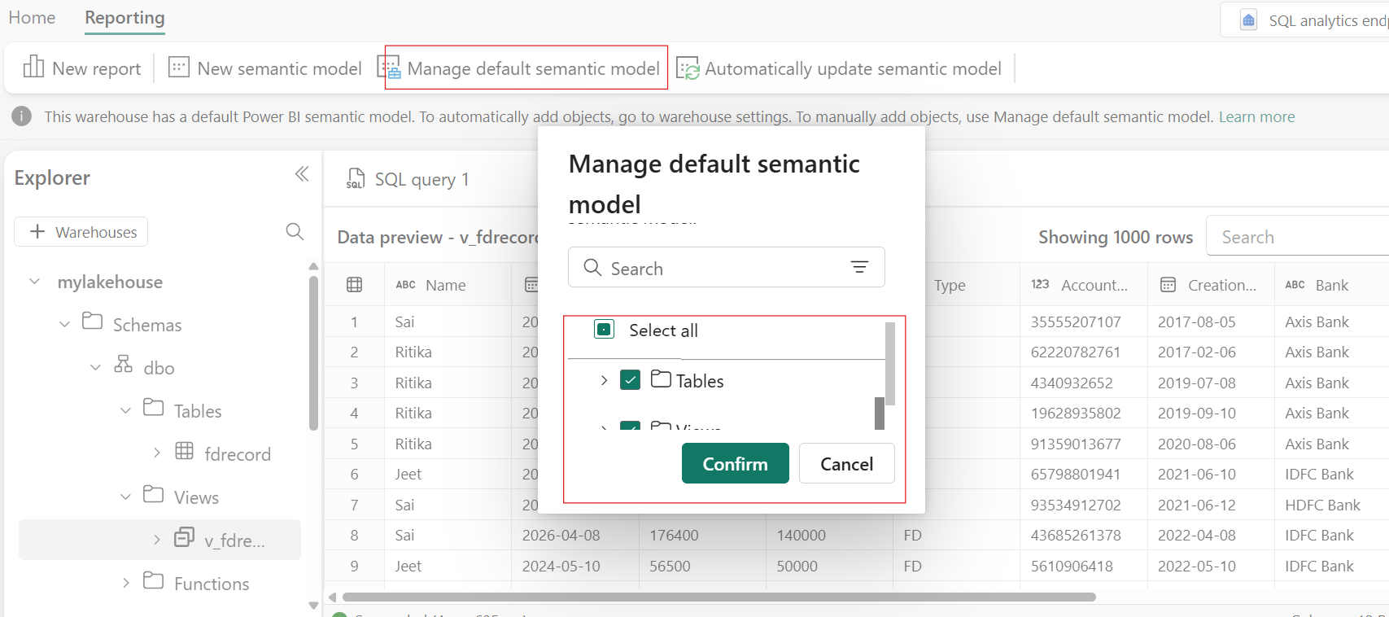

1. Now we can Power BI dashboard using this data.

1. Then Power BI report was created. (IDFC has largest share of FDs and Jeet invested max in FDs)

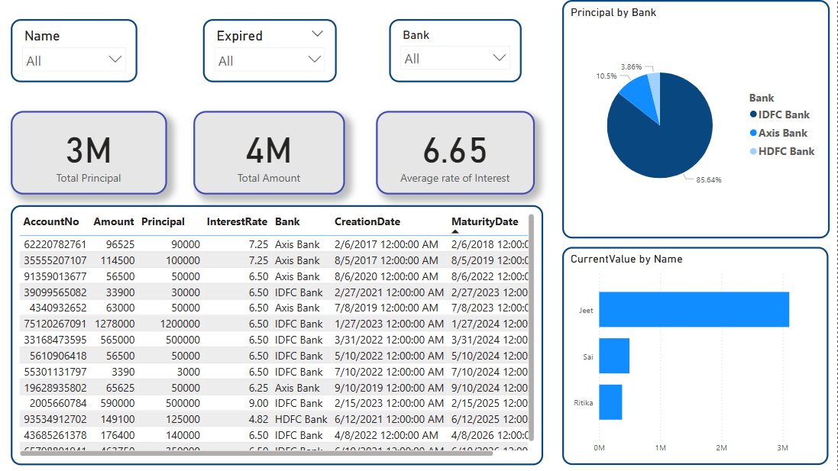

*Slicer wise: (IDFC Bank FDs which are expired)*

